Simpsons 2 – Level Breakdown July 2, 2002

Level One - Suburbs

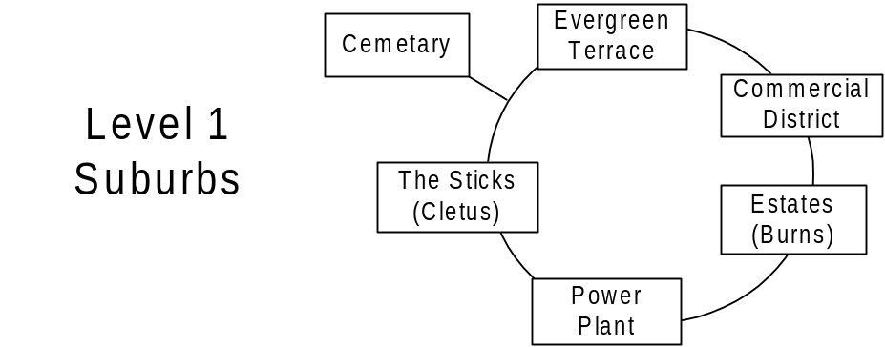
District 1 (Evergreen Terrace)
- Evergreen Terrace
  - Simpsons’ House (interior)
  - Flanders’
  - Ruth Powers
  - Rev. Lovejoy
  - Lenny
  - Apu (with for sale sign)
- School
  - School (interior)
  - Milhouse
  - Principle Skinner
  - Wiggam

District 2 (Commercial)
- Commercial
  - Krusty Burger
  - Gas Station
  - Kwik-E-Mart (interior)
  - Lard Lads
- Church
  - Church
  - Retirement Castle (interior)
  - Community Center

District 3 (Estates)
- Estates
  - House o’ Burlesque
  - Brockmans’
  - Krusty’s
  - Quimby Mansio
  - Malibu Stacy
- Burns Mansion (interior)
  - Maze (out of car puzzle)

District 4 (Power Plant)
- Power Plant
  - Offices
  - Interior (out of car puzzle)
  - Interior (interior)

District 5 (Sticks)
- Sticks
  - Nelsons House
  - Cletus’ House
  - Moe’s House

District 6 (Cemetery)
- Cemetery (bonus – loadable chunk)

Level Two - Downtown

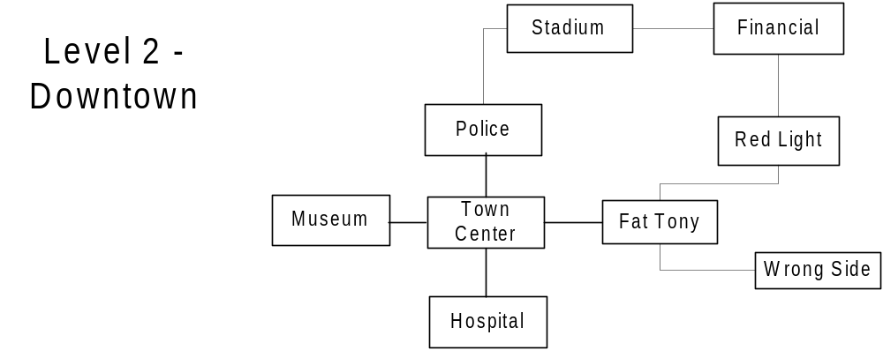
District 1 (Town Center)
- Town Square
  - Moes (interior)
  - King Toots
  - Town Hall (interior)
  - Post Office
  - Court House
  - Park
  - Zesty
  - Gas Station
  - DMV (interior)
- Hospital
  - Operation Room
- Police Station
  - Jail and Booking room (interior)
- Museum of Natural Art
  - WWII exhibit
  - Dinosaur exhibit (interior)
- Little Italy
  - Fat Tony’s

District 2 (Lower East Side)
- Wrong side of the Tracks
  - Plasma center
  - Helter Shelter
  - Veterans of Popular Wars
  - Herman’s Antiques (interior)
  - Blood Bank
  - Car Wash
  - Krusty Burger
  - Gas Station
- Red-light District
  - She She
  - Horny Toad
  - Nudes @ 11
  - Adam and Adam
  - Girlesque

District 3 (Financial)
- Financial
  - Sit ‘n Rotate (unlockable interior)
  - Up & Up Buffet
  - Escalator to Nowhere
  - State Building
  - Parade
  - Magnifying Glass/Popsicle Sky Scraper
  - Construction sites (out of car puzzle)
- Stadium
  - Playing field (Truckasauras) (out of car puzzle)
  - Concourse

Level Three - Seaside

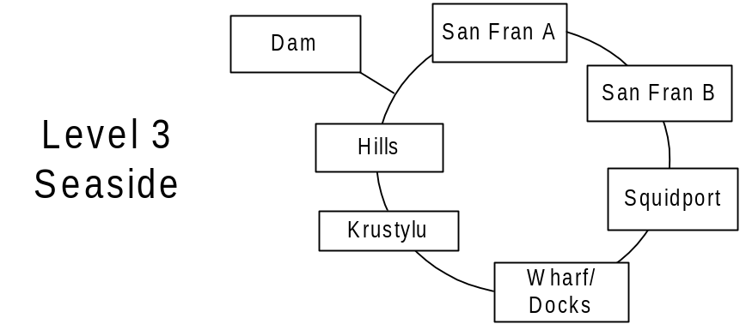

District 1 (Entertainment District)
- Scum (San Fran A)
  - No-Tell Motel
  - My 1st Tattoo
  - Gas Station
- Fun (San Fran B)
  - Noiseland Arcade (interior)
  - Android’s Dungeon (interior)
  - Wally Weasel
  - Bowl-a-Rama
- Restaurants
  - Aztec
  - Happy Sumo
  - Rusty Barnacle
  - Singing Sirloiner
  - Chez Perri

District 2 (Squidport)
- Squidport
  - Planet Hype
  - Two guys from Kabul
  - Gilded Truffle

District 3 (Docks)
- Wharf
  - Ships (out of car puzzle – loadable chunk)
  - Crates(out of car puzzle – loadable chunk)
- Krusty Lu
  - Krusty Stage (unlockable interior)
  - Simpsons’ Stage
- Duff Brewery
  - Interior (unlockable interior)

District 4 (Hills)
- Lower Hills (Hills A)
  - Observatory
  - Sign
- Upper Hills
  - Kamp Krusty
- Dam

